Name : Sakthi Manoj R Reg No : 192324236
PROGRAM 11
Write an R Program to Read a CSV File and Display Its Contents
Aim:
To read data from a .csv file using the read.csv() function and display its contents.
Procedure:
Step 1: Open RStudio or the R console on your computer.
Step 2: Use the read.csv() function to load data from a CSV file into an R data frame.
Step 3: Store the imported data in a variable for further use.
Step 4: Display a message indicating that the file contents are being printed.
Step 5: Print the data frame to view all rows and columns from the CSV file.
Output :
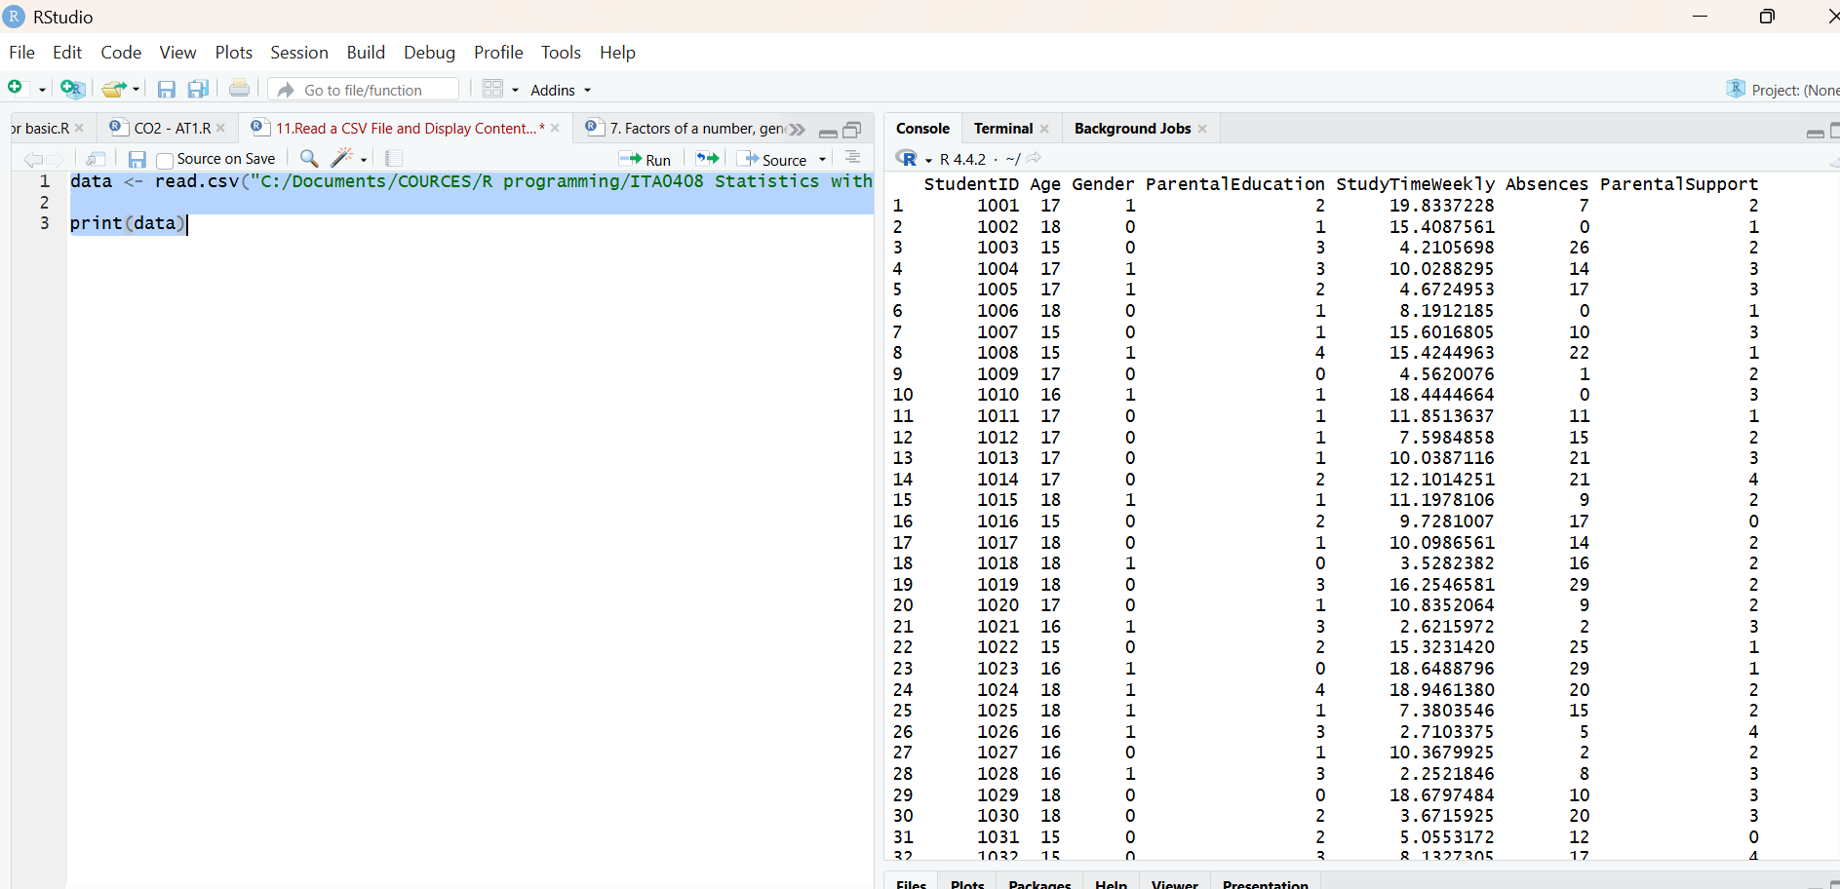
Result:
Hence the output is verified successfully.

